MODULE-1

HTML QUESTIONS & ANSWERS

**[ARPIT SIR]**

1.Are the HTML tags and elements the same thing?

Ans:

No, HTML Tags and Elements are not same.

HTML Tags:

Tags are used to hold the HTML element.

Tags are start with < and close with />

HTML elements:

Elements are hold the content.

Example: <b>This is my first assignment</b>

here, <b> is starting tag and </b> is

ending tag and This is my first

assignment is Elements.

2.What are tags and attributes in HTML?

Ans:

In, HTML Tags and Attributes are basic.

HTML Tags:

Tags are used to hold the HTML element.

Tags are start with < and close with />

HTML Attributes:

HTML Attributes are used to describe the proper data of an HTML element in detail.

Example:

<img src="mydog.jpg" alt="A photo of my dog.">

Here, src and alt are attributes.

3.What are void elements in HTML?

Ans:

This is special group of elements that only have a start tags but does not have ending tags.

This element are called a void elements.

Example:

<br>, <hr>, <img>, <input>, <link> etc.

4.What are HTML Entities?

Ans:

An HTML entity is a piece of text ("string") that begins with an ampersand (&) and ends with a semicolon (;).

Emojis number: &#128512, &#128513, &#128514

5.What are different types of lists in HTML?

Ans:

There are three types if list in HTML.

unordered list — used to group a set of related items in no particular order.

ordered list — used to group a set of related items in a specific order.

description list — used to display name/value pairs such as terms and definitions.

6.What is the ‘class’ attribute in HTML?

Ans:

Definition and Usage. The class attribute specifies one or more class names for an element. The class attribute is mostly used to point to a class in a style sheet. However, it can also be used by a JavaScript (via the HTML DOM) to make changes to HTML elements with a specified class.

7.What is the difference between the ‘id’ attribute and the ‘class’ attribute of HTML elements?

Ans:

In Html for an element ID name starts with the “#” symbol followed by a unique name assigned to it.

On the other hand class assigned to an element has its name starts with “.” followed by class name.

8.What are the various formatting tags in HTML?

Ans:

Formatting elements were designed to display special types of text: -

<b> - Bold text

<strong> - Important text

< I > - Italic text

<em> - Emphasized text

<mark> - Marked text

<small> - Smaller text

<del> - Deleted text

<ins> - Inserted text

<sub> - Subscript text

<sup> - Superscript text

9.How is Cell Padding different from Cell Spacing?

Ans:

Cell padding means to leave space

Between cell box or to insert the size of cell

And cell spacing means to leave the space between the cell border.

10.How can we club two or more rows or columns into a single row or column in an HTML table?

Ans:

with the help of Col span and row span we club two or more rows or columns into a single row or column in an html.

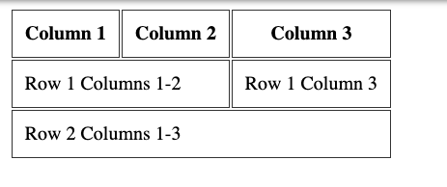

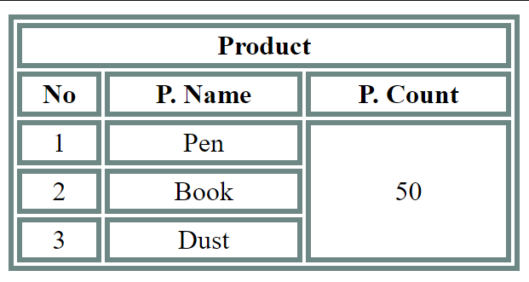

11.What is the difference between a block-level element and an inline element?

Ans:

the block level elements is that in which we put any bg colour format and convert the particular full row into it is called block level elements,

And in inline elements consists of text background colour changes but not of particular full row.

12.How to create a Hyperlink in HTML?

Ans:

to create hyperlink in html we have to add href

Means hyper referral link in <a></a>.

For example -: <a>href=” https//www.google.com ”</a>

13.What is the use of a span tag? Explain with example?

Ans:

the use of span tag is to merge anything such as, row, columns etc. with the help of col span we can merge columns and with the help of row span we can merge rows.

14.What is the use of an i-frame tag?

Ans:

An I-Frame, also knowns as Inline Frame, is an element that loads another HTML element inside of a web page. They are commonly used to embed specific content like external ads, videos, tags, or other interactive elements into the page.

15.How to insert a picture into a background image of a web page?

Ans:

With the help of CSS we can insert the picture into background image.

And,

To set the background image of a webpage, use the CSS

style. Under the CSS <style> tag, add the property backgroundimage. The property sets a graphic such as jpg, png, svg, gif, etc.

HTML5 do not support the <body> background attribute, so CSS

is used to change set background image.

16.How are active links different from normal links?

Ans:

Some browsers recognize an active link when the mouse cursor is placed over that link; others recognize active links when the link has the focus. Those that don’t have a mouse cursor over that link is considered a normal link.

17.What are the different tags to separate sections of text?

Ans:

There are three tags that can be used to separate the

texts:

<br> tag – Usually <br> tag is used to separate the line of

text. It breaks the current line and conveys the flow to the next

line.

<p> tag – This contains the text in the form of a new

paragraph.

<blockquote> tag – It is used to define a large quoted

section.

18.What is SVG?

Ans:

the full form of scalar variable graphics

It is used to insert any shapes colour and use to design in it.

19.What is difference between HTML and XHTML?

Ans:

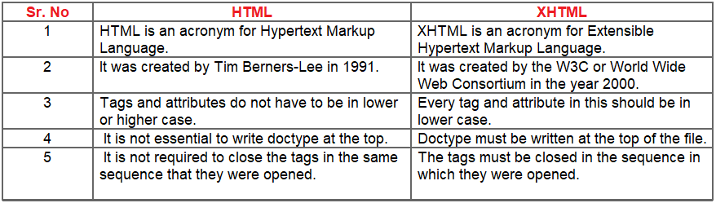

20.What are logical and physical tags in HTML?

Ans:

Logical tags describe the behaviour, nature of content for the text enclosed inside the tag. They represent the function of text on the page.

Physical tags are used to decide the appearance of the text and do not provide any information about the text.

***Assignment Written By: Mihir A. Patel***